Enabling Hive Metastore High Availability Using Cloudera Manager

**Minimum Required Role:** [**Configurator**](https://www.cloudera.com/documentation/enterprise/5-5-x/topics/cm_sg_user_roles.html#concept_wfh_tvy_qp) (also provided by **Cluster Administrator,** **Full Administrator**)

1. Go to the Hive service.
2. If you have a secure cluster, enable the Hive token store. Non-secure clusters can skip this step.

If more than one role group applies to this configuration, edit the value for the appropriate role group. See [Modifying Configuration Properties Using Cloudera Manager](https://www.cloudera.com/documentation/enterprise/5-5-x/topics/cm_mc_mod_configs.html" \l "cmug_topic_5_3).

* 1. Click the **Configuration** tab.
  2. Select **Scope** > **Hive Metastore Server**.
  3. Select **Category** > **Advanced**.
  4. Locate the **Hive Metastore Delegation Token Store** property or search for it by typing its name In the Search box.
  5. Select org.apache.hadoop.hive.thrift.DBTokenStore. 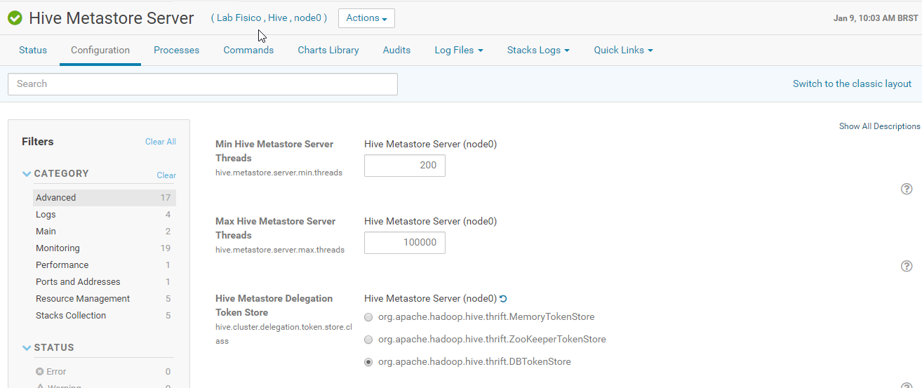
  6. Click **Save Changes** to commit the changes.

1. Click the **Instances** tab.
2. Click **Add Role Instances**.

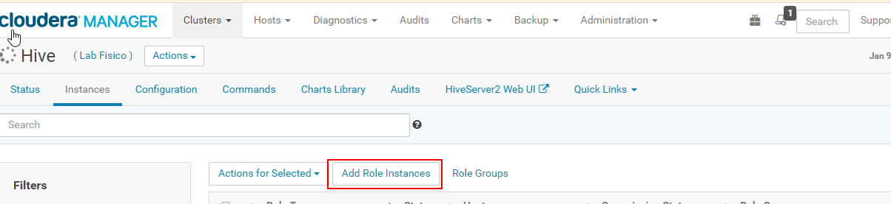

1. Click the text field under **Hive Metastore Server**.
2. Check the box by the host on which to run the additional metastore and click **OK**.
3. Click **Continue** and click **Finish**.
4. Check the box by the new **Hive Metastore Server** role.
5. Select **Actions for Selected** > **Start**, and click **Start** to confirm.
6. Click **Close** and click to display the stale configurations page.
7. Click **Restart Stale Services** and click **Restart Now**.
8. Click **Finish** after the cluster finishes restarting.